

American International University-Bangladesh (AIUB)

**Department of Computer Science**

**Faculty of Science & Technology (FST)**

**Research Methodology**

**Assignment**

Submitted By

|  |  |  |  |  |  |
| --- | --- | --- | --- | --- | --- |
| **Semester: Summer_2023-2024 FINAL TERM** | | | | **Section:** | **Group No:** |
| SL | SN | Student Name | Student ID | Individual  Contribution (100%) | Total Marks: 40 |
| Earned Marks: |
| **A** | 09 | Md. Shohanur Rahman Shohan | 22-46013-1 | 32% |  |
| **B** | 29 | Farjana Yesmin Opi | 22-47018-1 | 30% |  |
| **C** | 30 | Md. Abu Towsif | 22-47019-1 | 38% |  |
| **D** |  |  |  |  |  |

Submission Date: 19th February, 2024

**The assignment will be Evaluated for the following Course Outcomes**

|  |  |
| --- | --- |
| CO1: *Evaluate* all relevant resources for designing a computer science and engineering solution and determine the level of novelty of the research. | Total Marks (9) |
|  |
| **Problem Analysis and use of State-of-the-Art** **Resources:** Discuss the research problem background with best use of state‐of‐art literature, resources, and technologies to produce a significant result that is likely to have a major impact. | [3 Marks] **A: B: C: D:** |
| **Critical Reflection and Creativity in Research Objective:** Deep insight demonstrated and presented a creative solution to the real‐life problem. And Results are critically confronted with various existing literature | [3 Marks] **A: B: C: D:** |
| **Novelty and Contribution of the Research:** Elaborately discuss and identify the contribution of the research to the development of scientific concepts by recognizing the research gaps of existing research and developments. | [3 Marks] **A: B: C: D:** |

|  |  |
| --- | --- |
| CO2: *Analyze* the collected data to provide valid solution of the research problem acknowledging the limitations. | Total Marks (9) |
|  |
| **Data Analysis:** Elaborately discuss the research method, its appropriateness and details on data collection, analysis, and synthesis for proposing valid solution to the research problem. | [3 Marks]  **A: B: C: D:** |
| **Solution and Validation:** Elaborately discuss the solution of the research problem by establish a direct connection between proposed solutions with the research objective based on the collected research data. | [3 Marks]  **A: B: C: D:** |
| **Limitation and Scope of Future Studies:** Elaborately discuss abstract and concluding remarks of the research with its limitations and scope of future studies. | [3 Marks]  **A: B:  C: D:** |

|  |  |
| --- | --- |
| CO3: Determine and Demonstrate professional codes of ethics and standard in conducting research considering public safety; the impacts of engineering activity; economic, social, cultural, environmental and sustainability. | Total Marks (9) |
|  |
| **Free of Plagiarism, Data Falsification Citations and References:** Submit plagiarism free research paper (similarity index is <10%). In-text citations and reference list citations were complete and properly formatted in APA or any other standard style. The Research data is not fabricated or altered intentionally to fit into the predetermined research findings. Materials are properly cited and referenced if they are taken from other sources. And not attributed to a source from which it has not been obtained *(i.e., false citation)* | [3 Marks]  **A: B: C: D:** |
| **Professional codes of ethics and standard:** The research elaborately demonstrates professional codes of ethics and standard in conducting research considering public safety; the impacts of engineering activity; economic, social, cultural, environmental and sustainability. | [3 Marks]  **A: B: C: D:** |
| **Formatting and Submission:** Submitted in due time, the report is complete and there are no errors in spelling, format, and grammar. Consistently  presents a logical and effective organization. | [3 Marks]  **A: B: C: D:** |

|  |  |
| --- | --- |
| CO4: *Defend* the research solutions based on complex engineering activities by delivering an effective presentation to the audience. | Total Marks (9) |
|  |
| **Presentation delivery (eye contact and body language):** Keeps eye contact with audience all the time, use natural gestures and movements, looks confident. | [3 Marks]  **A: B: C: D:** |
| **Enthusiasm/Audience Awareness:** Demonstrate strong enthusiasm about the topic, significantly increases audience understanding and knowledge of the topic, convinces an audience to recognize the validity and importance of the subject. | [3 Marks]  **A: B: C: D:** |
| **Creativity and Use of Media:** The presentation was creative in design and effectively use multimedia. | [3 Marks]  **A: B: C: D:** |

|  |  |
| --- | --- |
| Viva/Defense | Total Marks (4) |
| Defend the research in performance in the question/answer session. | **A: B: C: D:** |

Designing an Intelligent Accommodation System for Rohingya Refugees: Integrating AI, Sustainability, and Economic Empowerment

MD. Abu Towsif, Farjana Yesmin Opi, Md. Shohanur Rahman Shohan  
Department of Computer Science  
American International University – Bangladesh  
(22-47019-1, 22-47018-1, 22-46013-1) @student.aiub.edu

**Abstract**

This paper presents a framework for an intelligent accommodation system aimed at enhancing living conditions, security, and economic opportunities for Rohingya refugees. Through a systematic literature review (SLR), the study identifies challenges and proposes an AI-driven model with sustainable infrastructure and community-focused strategies. The framework seeks to improve resource management, security, and productivity within refugee camps, addressing both immediate and long-term needs. Findings highlight the potential of integrating technology and local knowledge to promote self-sufficiency and stability, offering valuable insights for policymakers and humanitarian organizations.

**Keywords:** Sustainable Refugee Housing, AI-Driven Solutions, Rohingya Refugee Accommodation, Refugee Productivity, Economic Empowerment

INTRODUCTION

**Problem Background**

The Rohingya, a persecuted ethnic minority from Myanmar, face severe displacement, with nearly 1,000,000 refugees in makeshift camps in Bangladesh (United Nations High Commissioner for Refugees, n.d.). Innovative solutions are needed to provide accommodation and foster self-sufficiency (Milton et al., 2017). The influx, particularly in Cox’s Bazar, strains resources and infrastructure. Traditional camps offer immediate relief but often neglect long-term sustainability and economic potential (Bhatia et al., 2018).

Tasmin, a 51-year-old Rohingya woman, fled Myanmar in 2017 after extreme violence, journeying for eleven days before crossing the Naf River into Bangladesh. Her family joined nearly one million refugees in Kutupalong, facing overcrowded conditions, inadequate shelter, and food shortages (Relief International, 2019). This story highlights the trauma and challenges many refugees experience in the camps.

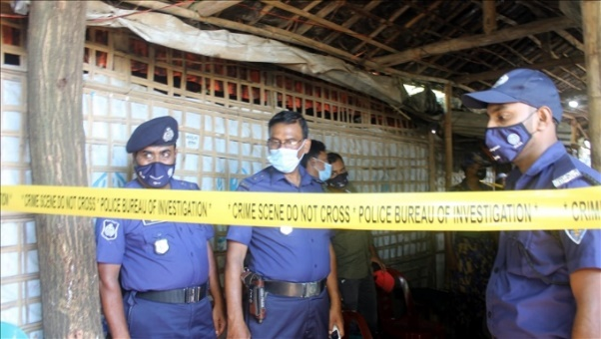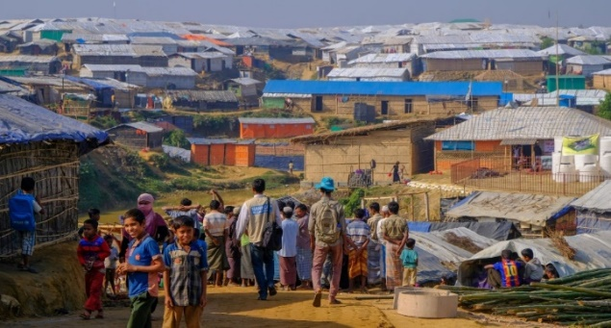

Figure 2 - Police guard madrassa after Rohingya attack in Cox’s Bazar, Oct. 26, 2021. (Benar News, 2021)

Figure 1 - Kutupalong Refugee Camp (Humanity & Inclusion Canada, n.d.)

Moreover, crimes such as murders and drug offenses, linked to groups like ARSA and RSO, have surged in the camps (The Daily Star, 2023). The situation is worsened by Rohingya refugees using fake Bangladeshi IDs, causing instability and fear (Dhaka Tribune, 2023). Contributing factors include limited economic opportunities and hopelessness, leading jobless youths to crime, with armed groups fueling illegal activities and escalating violence (Dhaka Tribune, 2023). The problems that this research aims to address can be broadly summarized into two main issues:

* **Inadequate living conditions and lack of long-term sustainability**: Current refugee accommodations hinder the economic self-sufficiency and social productivity of Rohingya refugees.
* **Escalating security problems within camps**: Issues such as crime and the misuse of identification documents further destabilize the already precarious environment.

This paper addresses the critical need to rethink refugee accommodation from a perspective that includes productivity, self-reliance, and enhanced security.

**Related Studies**

In order to address the above discussed problems several studies examined conditions of Rohingya refugee camps. Bhatia et al. (2018) highlight inadequate facilities and economic opportunities but offer no long-term solutions. Milton et al. (2017) focus on health challenges from overcrowding and poor sanitation but overlook socio-economic factors and technology's role. Karin et al. (2020) emphasizes the critical dearth of food, inadequate housing facilities, and poor access to health services in Rohingya refugee camps but do not explore the potential role of technological advancements in addressing these issues. Hossain et al. (2020) address rising crime and armed groups but do not explore how AI could enhance security.

Despite the valuable contributions of these studies, there is a noticeable gap in the literature regarding integrated solutions that combine sustainable living conditions with productivity-enhancing features and advanced technologies like AI. None of the existing research comprehensively addresses the need for a holistic accommodation system that not only meets the basic needs of refugees but also empowers them to achieve economic self-sufficiency and social productivity while ensuring their security.

This research aims to fill that gap by proposing an intelligent accommodation system that incorporates AI to optimize resource allocation, enhance security, and support economic integration within the refugee camps. By addressing these gaps, this study will contribute significantly to the field of humanitarian aid and refugee studies, offering a model that can be adapted and implemented in similar contexts globally.

**Research Objectives**

This research proposes an intelligent accommodation system for Rohingya refugees that combines sustainable living, productivity enhancement, and improved security. The objective is to develop a framework that addresses immediate needs such as shelter and healthcare, while also focusing on long-term sustainability through environmental practices and resource management. The system will integrate economic activities to promote self-reliance and utilize AI to address security issues and optimize resources. The study will present a conceptual model to explore the answer of "How to develop an accommodation system that supports productivity, ensures security, and leverages AI?”

**Research Contributions**

This study contributes to humanitarian aid, refugee studies, and AI-driven social innovation by presenting a framework for intelligent accommodation systems tailored to Rohingya refugees. It provides insights for policymakers and organizations on using AI to create sustainable, secure environments while enhancing refugee productivity. By integrating AI in resource management and security, the research offers solutions that reduce refugee dependency, promote self-sufficiency, and alleviate the socio-economic burden on host countries

methodology

This study employs a systematic literature review (SLR) to evaluate research on intelligent accommodation systems for Rohingya refugees, ensuring a thorough and unbiased data collection (Kitchenham et al., 2010; Petersen et al., 2008). The SLR method was chosen for its comprehensive approach and ability to form a robust framework by systematically analyzing relevant literature.

#### Search Strategy

The search strategy targeted relevant academic sources across IEEE Xplore, SpringerLink, ScienceDirect, ACM Digital Library, IGI Global, Google Scholar, and Wiley Online Library. These databases offer extensive coverage of technological and humanitarian literature, essential for the interdisciplinary nature of this research.

#### Keywords and Boolean Logic

A strategic combination of carefully selected keywords and Boolean operators was used to refine and target the search results. The terms "Rohingya refugees" AND "accommodation system" AND "artificial intelligence," "refugee productivity" OR "sustainable refugee camps," and "AI in refugee security" AND "systematic review" were applied. This approach ensured a comprehensive yet focused search, capturing relevant studies efficiently.

#### Forward and Backward Search Techniques

In addition to database searches, forward and backward citation techniques were employed to review key article references and identify more recent studies. This comprehensive approach ensured that all relevant and recent literature was included in the review.

#### Inclusion and Exclusion Criteria

To ensure the relevance and quality of the literature, specific inclusion and exclusion criteria were applied. The inclusion criteria focused on peer-reviewed journal articles and conference papers published in English between 2000 and 2024, with a focus on refugee accommodation, AI applications in humanitarian settings, and security. Exclusion criteria ruled out non-peer-reviewed materials, studies not directly addressing AI or refugee accommodation systems, articles with only relevant titles but lacking substantive content in the abstracts or full texts, and publications without sufficient methodological rigor.

#### Selection Process

The selection process was designed to systematically screen studies based on their relevance to the research question

#### Initial Screening

#### An initial search of academic databases yielded 87 articles, with titles and abstracts reviewed for relevance to AI, refugee accommodation, and security.

#### Secondary Filtering

The inclusion and exclusion criteria narrowed the list to 30 articles by filtering out those lacking peer-reviewed rigor or relevance to AI-driven systems for Rohingya refugees.

#### Final Selection

A detailed review led to the final selection of 11 studies, chosen for their direct relevance and methodological rigor, including both full texts and abstracts

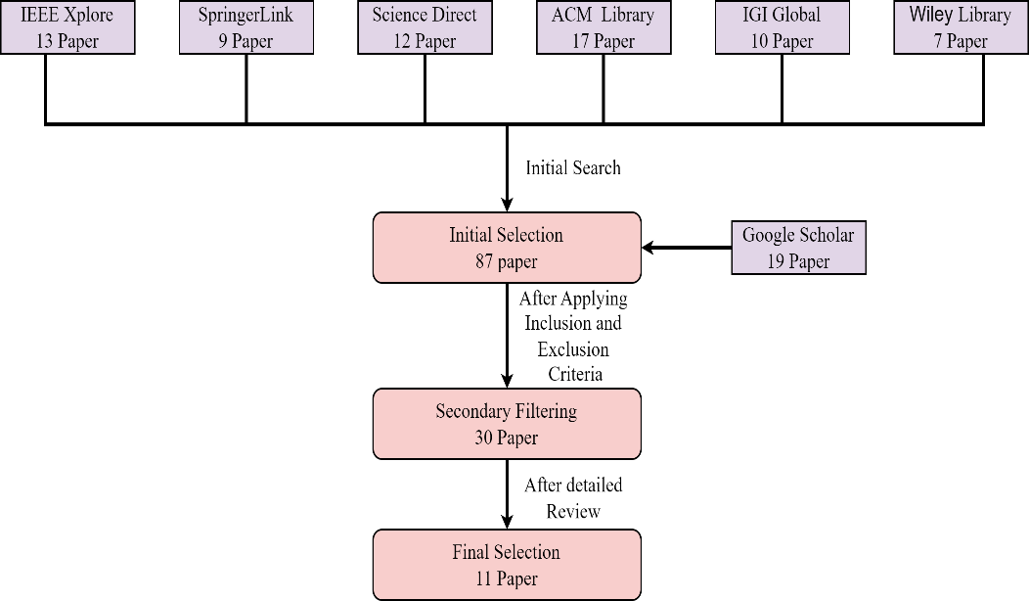

**Figure 3 -** Literature Search and Article Selection for Systematic Review

#### Data Extraction and Synthesis

#### A standardized approach was used to extract detailed information from available sections of freely accessible articles, while focusing on key data from articles with limited access.

#### Data Extraction Process

A standardized form was employed to extract data from abstracts, methodology, results, and conclusions of fully accessible articles, while key information was collected from restricted-access papers.

#### Quality Assessment

Quality assessment was based on citation count, journal impact, and methodological rigor. This ensured the inclusion of high-quality studies, enhancing the credibility and impact of the research findings.

results and analysis

**Research Data/Results**

The following table summarizes the key findings from the reviewed literature, highlighting relevant insights and data that inform the development and validation of the proposed solution

|  |
| --- |
| Top row contains titles, while the rows below the title contains findings from the reviewed literature |
| **Alam, F. R., Munir, M. B., Ishrak, S., Hussain, S., Reza, F., Khan, N. S., Tumpa, S. N. & Karim, M. M. (2018). *An automated cloud-based digitized management system for Rohingya refugee camp in Bangladesh.* 2018 International Conference on Electrical, Computer, and Communication Engineering (ECCE), Chonburi, Thailand.** |
| The study proposes a cloud-based system to improve refugee accommodation management by centralizing resource tracking and refugee information. Biometric identification enhances security and resource allocation, creating a more efficient and productive environment. |
| **Wardeh, M., & Marques, R. C. (2021). Sustainability in refugee camps: A systematic review and meta-analysis. *Sustainability*, *13*(14), 7686** |
| The review highlights the importance of sustainable planning in refugee camps by integrating local knowledge and technology. Focus areas include health, education, and economic growth, with long-term policies crucial for improving the Rohingya community's quality of life. |
| **Dala, A., Darweesh, A., Misselwitz, P., & Steigemann A. (2018). Planning the Ideal Refugee Camp A Critical Interrogation of Recent Planning Innovations in Jordan and Germany. *Urban Planning, 3*(4), 64** |
| The paper calls for improved refugee shelter design by integrating urban planning to boost productivity and security. It critiques rigid bureaucratic systems, advocating for more flexible, self-determined living arrangements to empower refugees, especially the Rohingya. |
| **Sabie, D., & Ahmed, S. I. (2019). *Moving into a technology land: exploring the challenges for the refugees in Canada in accessing its computerized infrastructures.* COMPASS '19: Proceedings of the 2nd ACM SIGCAS Conference on Computing and Sustainable Societies, Accra, Ghana.** |
| The paper emphasizes the need for inclusive technology design to overcome barriers faced by refugees, particularly women, in accessing technology. Addressing these challenges through an intelligent accommodation system could enhance resource access, digital skills, and security for Rohingya refugees. |
| **Marji, N., & Kohout, M. (2022). *From Temporary Shelter to Permanent Dwelling: Optimizing the Spatial Organization of Refugee Camps in Jordan through Artificial Intelligence.* Academic Mindtrek 2022: 25th International Academic Mindtrek conference, Tampere, Finland.** |
| The paper advocates for using AI in refugee camps to improve spatial organization, enhance living conditions, and ensure security through better resource management. Involving refugees in the design process fosters more sustainable and productive accommodation solutions. |
| **Hossain, S. M., Zhang, H., Hossain, M. S., & Yun, L. (2020). Rohingya Refugee Crisis: Security Concerns for Bangladesh. *South Asian Journal of Social Studies and Economics 8*(2), 24-34.** |
| The paper underscores the need for a structured approach to the Rohingya refugee crisis, focusing on security and the safe return of refugees. It highlights vulnerabilities due to irregular status and limited resources, suggesting that an intelligent accommodation system could enhance productivity and address security concerns through effective management. The study also emphasizes the importance of international cooperation and humanitarian support for creating a sustainable environment for refugees. |
| **Easen, O., & Binatli, A. O. (2017). The Impact of Syrian Refugees on the Turkish Economy: Regional Labour Market Effects. *Social Sciences, 6*(4), 129** |
| The paper highlights that the influx of refugees, like Syrians in Turkey, significantly affects local labor markets, often increasing unemployment and informal employment. It emphasizes the need for effective integration strategies to enhance productivity and security. These insights can guide the development of an intelligent accommodation system for Rohingya refugees, focusing on labor market integration and secure living conditions to foster community stability. |
| **İncetahtacı, N. (2024). The role of university-NGO cooperation in increasing the entrepreneurial skills of youth: An evaluation specific to refugee youth. *International Journal of Education, 39*(2), 507-523.** |
| The paper stresses the need for structured solutions to the Rohingya crisis, focusing on security, safe return, and international cooperation. It suggests an intelligent accommodation system to enhance productivity and address security concerns. |
| **Georgious, T., Baillie, L., & Shah, R. (2023). Investigating Technology Concepts to Support Rohingya Refugees in Malaysia. doi:10.48550/arXiv.2304.01617** |
| The paper highlights how refugee influxes, like Syrians in Turkey, affect local labor markets, underscoring the importance of integration strategies. These insights can inform the development of secure and productive accommodation systems for Rohingya refugees. |
| **Filipski, M. J., Rosenbach, G., Tiburcio, E., Dorosh, P., & Hoddinott, J. (2020). Refugees Who Mean Business Economic Activities in and Around Rohingya Settlements in Bangladesh. *Journal of Refugee Studies, 34*(1), 1202-1242.** |
| The study emphasizes the need for addressing legal, resource, and cultural barriers to improve refugee youth productivity. Collaborations between universities and NGOs can empower refugees, enhancing their economic contributions and social cohesion. |
| **Wolf, S. (2014). The Rohingyas crisis: a security perspective from Bangladesh. *APSA Comment, 11*(21), 1-11.** |
| The paper identifies the Rohingya crisis as a non-traditional security threat in Bangladesh, fueling religious fundamentalism and straining governance. Addressing transnational crime and distinguishing between moderate and radical elements is essential for regional stability. |

**Analysis and Discussion**

Based on the above findings from the selected papers, the proposed solution integrates an AI-driven centralized data management system for improved resource tracking, identification, and security. This approach focuses on enhancing the living conditions of refugees by incorporating sustainable infrastructure and promoting economic self-sufficiency through employment opportunities and community integration within the camps.

1. **Centralized Data Management and Identification:**

• Use AI-driven centralized databases for tracking resources and refugee profiles (Alam et al., 2018). Focus on biometric identification to improve security and resource distribution. This will streamline communication between humanitarian organizations and local authorities.

**2. Improved Refugee Living Conditions**:

• Implement sustainable infrastructure using innovative urban planning designs and local knowledge to boost self-determination and productivity. Include eco-friendly practices like solar power to reduce environmental impact.

**3. Economic Empowerment:**

• Create employment within camps using AI to match skills with opportunities (İncetahtacı, 2024; Filipski et al., 2020). Provide virtual training to enhance productivity and integrate refugees into the local economy.

**4. Enhanced Security Measures:**

• Incorporate AI-based surveillance and real-time monitoring systems to improve safety (Hossain et al., 2020). Community-based approaches can strengthen trust in security efforts.

**5. Community Integration and Social Cohesion:**

• Promote integration between refugees, host communities, and NGOs through education and mentorship programs (İncetahtacı, 2024). These initiatives should address legal and cultural barriers to support both refugees and host communities.

The diagram below illustrates the proposed solution, integrating key technological and community-focused strategies based on the proposed solutions

Figure 4 - Diagram of Proposed Ai driven accommodation system for Rohingya refugees

**Solution Validation**

The proposed intelligent accommodation system improves refugee support by integrating AI-driven resource management, spatial organization, and sustainable infrastructure. Marji and Kohout (2022) highlight AI’s role in optimizing camp layouts and resource management, supporting our system’s goals. İncetahtacı (2024) underscores the importance of economic empowerment, reinforcing the system's potential to enhance productivity and self-reliance among refugees. These studies validate the system's effectiveness in addressing existing gaps in refugee accommodation.

Conclusion

This paper presents a framework for an intelligent accommodation system to improve the living conditions, security, and economic opportunities for Rohingya refugees. By integrating AI-driven systems with sustainable infrastructure, the solution focuses on both immediate relief and long-term self-sufficiency, based on a comprehensive literature review.

While the framework offers a strong theoretical model, it remains conceptual and lacks real-world testing. Future research should explore its practical implementation, scalability, and adaptability to ensure its effectiveness in various refugee contexts.

**REFERENCES**

Ahad, S. S. (2024). *Detectives reveal how Rohingyas obtain fake documents.* Available at https://www.dhakatribune.com/bangladesh/crime/340383/detectives-reveal-how rohingyas-obtain-fake. Accessed on September 14, 2024.

Alam, F. R., Munir, M. B., Ishrak, S., Hussain, S., Reza, F., Khan, N. S., Tumpa, S. N. & Karim, M. M. (2018). *An automated cloud-based digitized management system for Rohingya refugee camp in Bangladesh.* 2018 International Conference on Electrical, Computer, and Communication Engineering (ECCE), Chonburi, Thailand.

Barua, S., & Chowdhury, K. R. (2021, October 26). *Bangladesh: Rohingya express fear after killings of leader, 6 others.* Available at https://www.benarnews.org/english/news/bengali/camp-fears-10262021163429.html. Accessed on September 13, 2024.

Bhatia, A., Mahmud, A., Fuller, A., Shin, R., Rahman, A., Shatil, T., Sultana, M., Morshed, K. A. M., Leaning, J., & Balsari, S. (2018). The Rohingya in Cox's Bazar: When the Stateless Seek Refuge. *Health and Human Rights, 20*(2), 105-122.

Dala, A., Darweesh, A., Misselwitz, P., & Steigemann A. (2018). Planning the Ideal Refugee Camp A Critical Interrogation of Recent Planning Innovations in Jordan and Germany. *Urban Planning, 3*(4), 64.

Easen, O., & Binatli, A. O. (2017). The Impact of Syrian Refugees on the Turkish Economy: Regional Labour Market Effects. *Social Sciences, 6*(4), 129.

Filipski, M. J., Rosenbach, G., Tiburcio, E., Dorosh, P., & Hoddinott, J. (2020). Refugees Who Mean Business Economic Activities in and Around Rohingya Settlements in Bangladesh. *Journal of Refugee Studies, 34*(1), 1202-1242.

Georgious, T., Baillie, L., & Shah, R. (2023). Investigating Technology Concepts to Support Rohingya Refugees in Malaysia. doi:10.48550/arXiv.2304.01617.

Handicap International. (n.d.). *Almost one million Rohingya refugees living in Bangladesh.* Available at https://www.hi-canada.org/en/news/almost-one-million-rohingya-refugees-living-in-bangladesh. Accessed on September 13, 2024.

Hossain, S., Zhang, H., Hossain, M. S., & Yun, L. (2020). Rohingya Refugee Crisis: Security Concerns for Bangladesh. *South Asian Journal of Social Studies and Economics, 8*(2), 24-34.

İncetahtacı, N. (2024). The role of university-NGO cooperation in increasing the entrepreneurial skills of youth: An evaluation specific to refugee youth.*International Journal of Education, 39*(2), 507-523.

Karin, S., Chowdhury, M. A., Hasnat, M. A., & Tarin, N. J. (2020). Status of Rohingya in refugee camps of Bangladesh: A review study. *Open Access Library Journal*, *7*(9), 1-24.

Khan, M. J., & Jinnat, M. A. (2023). *Refugee camps: Killings, narco-crimes rise.* Available at https://www.thedailystar.net/news/bangladesh/crime-justice/news/refugee-camps-killings-narco-crimes-rise-3402601. Accessed on September 14, 2024.

Marji, N., & Kohout, M. (2022). *From Temporary Shelter to Permanent Dwelling: Optimizing the Spatial Organization of Refugee Camps in Jordan through Artificial Intelligence.* Academic Mindtrek 2022: 25th International Academic Mindtrek conference, Tampere, Finland.

Milton, A. H., Rahman, M., Hussain, S., Jindal, C., Choudhury, S., Akter, S., Ferdousi, S., Akter Mouly, T., Hall, J., & Efird, J. T. (2017). Trapped in Statelessness: Rohingya Refugees in Bangladesh. *International Journal of Environmental Research and Public Health, 14*(8), 942. https://doi.org/10.3390/ijerph14080942.

Relief International. (2019). *Rohingya Crisis: "I’ve Never Shared My Story Before."* Available at https://www.ri.org/rohingya-crisis-ive-never-shared-my-story-before/. Accessed on September 12, 2024.

Sabie, D., & Ahmed, S. I. (2019). *Moving into a technology land: exploring the challenges for the refugees in Canada in accessing its computerized infrastructures.* COMPASS '19: Proceedings of the 2nd ACM SIGCAS Conference on Computing and Sustainable Societies, Accra, Ghana.

United Nations High Commissioner for Refugees (UNHCR). (n.d.). *Bangladesh - Refugee Situation.* Available at https://data.unhcr.org/en/country/bgd. Accessed on September 12, 2024.

Wardeh, M., & Marques, R. C. (2021). Sustainability in refugee camps: A systematic review and meta-analysis. *Sustainability, 13*(14), 7686.

Wolf, S. (2014). The Rohingyas crisis: a security perspective from Bangladesh. *APSA Comment*, *11*(21), 1-11.